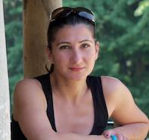 Pilates with Mandy

My main background is dance. I was very fortunate to study at the prestigious Laban Dance Centre in London.
After sustaining a back injury, I went to train at Alen Herdman studio, which made incredible differences to my recovery.
Alen Herdman was the very first person to introduce Pilates into the UK and being trained at his studio helped me develop my love and understanding for Pilates.
My appreciation on how effective Pilates can be on the body was taken to another level.

I furthered my education in the fitness industry and completed my mat work for Pilates with Training Solutions and Stott.

I have enjoyed teaching Pilates for over fifteen years and love learning and growing as a teacher.

My class is very rounded and adaptable to each persons needs. I am descriptive in the delivery of the class and make it fun so its enjoyable to all. I like to have a hands-on approach and adapt exercises to suit the individual’s needs.

